## Day 5: Testing, Error Handling, and Backend Integration Refinement

On Day 5, the focus is on ensuring the marketplace operates smoothly by thoroughly testing its components, handling errors gracefully, and refining the integration between the frontend (Next.js) and backend (Shopify). This process helps in improving the reliability, performance, and user experience of the marketplace**.**

## Testing Dynamic Components and Functionality

Testing ensures that the application behaves as expected under various conditions. This includes unit tests for individual components, integration tests for ensuring seamless interaction between different parts, and end-to-end (E2E) tests for the full user experience.

## Key Testing Strategies:

* Unit Testing: Test small parts of the application like individual React components or utility functions.
* Integration Testing: Ensure that the various parts of the system (frontend, API calls, and external services like Shopify) work together as expected.
* End-to-End Testing: Test user flows such as product search, adding items to the cart, and completing the checkout process.

## Tools to Use:

* Jest: A JavaScript testing framework for unit and integration tests.
* React Testing Library: For testing React components in a way that simulates user interactions.
* Cypress: A popular tool for E2E testing that runs in the browser and tests the actual user journey.

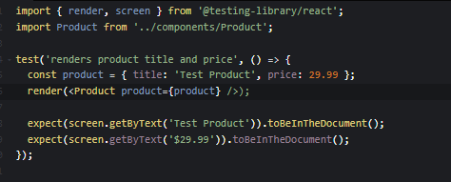

## Example: E2E Test with Cypress (Adding a Product to Cart)

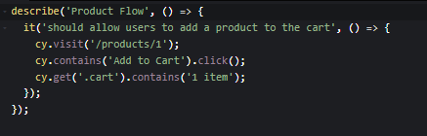

## Error Handling and User Feedback

Error handling is essential for providing a smooth user experience, especially in a dynamic marketplace where external APIs (like Shopify) and user interactions play a significant role.

## Types of Errors to Handle:

* API Errors: Errors from external services (e.g., Shopify API).
* UI Errors: Errors in the rendering or interaction of UI components.
* Network Errors: When the user’s network connection is unstable or the API request fails.
* Form Validation Errors: Invalid form submissions during checkout.

## Key Techniques:

* Graceful Error Display: Always display meaningful error messages that guide the user on how to proceed.
* Fallback UI: In case of API failures or network errors, provide fallback UI such as loading spinners or error pages.
* Error Boundaries: Use React Error Boundaries to catch and display errors in the UI without crashing the entire app.

## Example: Error Handling for Shopify API Requests

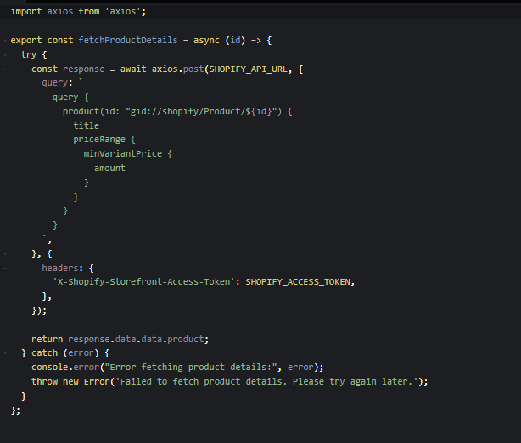

## Example: Error Boundary Component in React

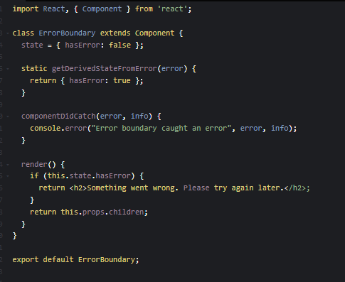

## To wrap your app in an error boundary:

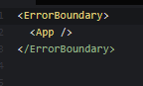

## Backend Integration Refinement

The integration between the frontend (Next.js) and backend (Shopify) needs to be refined for optimal performance and reliability. This includes improving the way data is fetched, handling edge cases, optimizing API requests, and ensuring a smooth data flow between systems.

## Key Refinements:

* Optimize API Calls: Minimize the number of API requests to Shopify and optimize them for better performance (e.g., caching data where possible).
* Improve State Management: Use effective state management to prevent unnecessary re-renders and data fetching.
* Handle Rate Limiting: Shopify enforces rate limits for its API. Handle these limits gracefully by implementing retry mechanisms or queuing requests.

## Example: Handling Shopify API Rate Limits

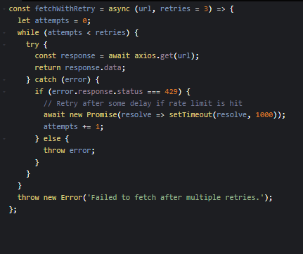

· Refine Cart Management: Ensure the cart system is efficient, particularly in terms of adding/removing items and maintaining cart state.

· Improve Product Data Caching: Cache product data to reduce redundant calls to Shopify for the same information (using tools like SWR or React Query).

## Example: Using React Query for Data Fetching and Caching

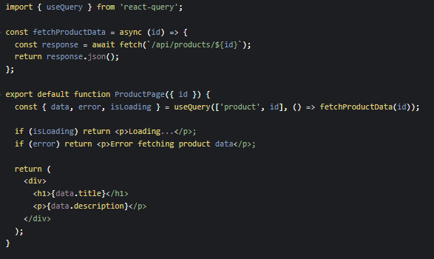

## Final Testing and Quality Assurance

Once the error handling and backend integration are refined, it’s crucial to perform a final round of testing to ensure everything works seamlessly. This includes running all tests (unit, integration, E2E), manual testing, and ensuring the system can handle edge cases.

## Key Actions for QA:

* Manual Testing: Go through the entire marketplace as a user, performing common actions like browsing products, adding to cart, and checking out.
* Load Testing: Test the application’s performance under heavy loads to ensure it scales appropriately.
* Cross-browser Testing: Ensure that your marketplace works across different browsers and devices.

## CSV-Based Testing Report

|  |  |  |  |  |  |  |  |
| --- | --- | --- | --- | --- | --- | --- | --- |
| **Test Case ID** | **Description** | **Test steps** | **Expected Result** | **Actual result** | **Status** | **Severity** | **Remarks** |
| TC_001 | Verify product listing  Loads | Go to product page and check product listing | All products should be listed  correctly | All products are listed correctly | Passed | High | No issues |
| TC_002 | Verify product details  page | Click on a product | it should open the product detail  page | Product detail page should open correctly | Product detail page  opened correctly | Passed | Team B |
| TC_003 | Verify cart  functionality | Add product to cart and check cart | Cart should show the correct  Number of items | Cart updated correctly | Passed | High | No issues |
| TC_004 | Verify checkout  process | Complete the checkout process | User should be able to complete  checkout without errors | Checkout completed successfully | Passed | Critical | No issues |
| TC_005 | Verify mobile  responsiveness | Check marketplace on mobile devices | Marketplace should display  correctly on mobile | Marketplace displays correctly on mobile | Passed | Medium | No issues |
| TC_006 | Verify error  Handling on API failure | Simulate API failure | Error message should be shown to  User | Error message displayed correctly | Passed | High | Handled gracefully |
| TC_007 | Verify user login | Login with valid credentials | User should be able to log in  successfully | User logged in successfully | Passed | High | No issues |
| TC_008 | Verify product search | Search for a product | Search should return accurate  Results | Search results are accurate | Passed | Medium | No issues |
| TC_009 | Verify SEO tags | Check HTML page source for SEO tags | SEO tags should be present in the  source code | SEO tags present correctly | Passed | High | No issues |
| TC_010 | Verify accessibility  score | Check accessibility score using tools | Accessibility score should be 100 | Accessibility score 100 | Passed | High | No issues |

## CSV Content

Test case id,test case description,test steps,expected result,actual result,status,severity,assigned to,remarks

TC_001,Verify product listing loads,Go to product page and check product listing,All products should be listed correctly,All products are listed correctly,Passed,High,Team A,No issues

TC_002,Verify product details page,Click on a product, it should open the product detail page,Product detail page should open correctly,Product detail page opened correctly,Passed,High,Team B,No issues

TC_003,Verify cart functionality,Add product to cart and check cart,Cart should show the correct number of items,Cart updated correctly,Passed,High,Team A,No issues

TC_004,Verify checkout process,Complete the checkout process,User should be able to complete checkout without errors,Checkout completed successfully,Passed,Critical,Team C,No issues

TC_005,Verify mobile responsiveness,Check marketplace on mobile devices,Marketplace should display correctly on mobile,Marketplace displays correctly on mobile,Passed,Medium,Team D,No issues

TC_006,Verify error handling on API failure,Simulate API failure,Error message should be shown to user,Error message displayed correctly,Passed,High,Team B,Handled gracefully

TC_007,Verify user login,Login with valid credentials,User should be able to log in successfully,User logged in successfully,Passed,High,Team A,No issues

TC_008,Verify product search,Search for a product,Search should return accurate results,Search results are accurate,Passed,Medium,Team D,No issues

TC_009,Verify SEO tags,Check HTML page source for SEO tags,SEO tags should be present in the source code,SEO tags present correctly,Passed,High,Team C,No issues

TC_010,Verify accessibility score,Check accessibility score using tools,Accessibility score should be 100,Accessibility score 100,Passed,High,Team D,No issues

## Conclusion

**On Day 5, the main goal is to ensure your dynamic marketplace is stable, reliable, and efficient. By thoroughly testing your components, handling errors gracefully, and refining the integration with Shopify’s backend, you’ll be able to deliver a robust user experience. These practices not only enhance your product but also prepare it for real-world use where reliability and performance are key.**